3, Melbourne Road,
Carlisle,
Cumbria.
CA1 2DW
Dear Friends,
Carlisle and Border Branch would like you to join us for our Beginners & Improvers Workshop followed by a short dance on Saturday 12th November 2022 at Thursby Parish Hall, Matty Lonning, Carlisle, CA5 6PQ. The teacher will be Mary Thomas and music for the classes and evening dance will be provided by Andrew Lyon.

Timetable:
1:00pm – 1:30pm – Registration including tea/coffee
1:30pm – 3:00pm – Class 1
3:00pm – 3:30pm – Break for tea/coffee and biscuits
3:30pm – 5:00pm – Class 2
5:00pm – Light meal break
6:30pm – 9:00pm – Dance with interval for tea/coffee and biscuits
,
Sandwiches, savoury snacks and tray bakes will be provided along with tea and coffee for the meal break between Class 2 and the dance

At the dance all dances will be recapped and walked through once

The Parish is approximately 6 miles West of Carlisle; There is limited parking outside the hall, but street parking is available.

Class sizes are limited so please book early. Places will be allocated on a first come first served basis.

Prices:

Class1/Class 2 £5 RSCDS Member or £6 Non-Member
Dance £5 RSCDS Member or £6 Non-Member;

Note RSCDS membership can be with any Branch

For further details or additional application forms please contact
Francis Reid email reid825@btinternet.com or visit our website rscdscarlisle.co.uk

For dance programme see overleaf:

Cumberland Reel | J | Bk 1 | New Year Jig | J | Bk 51
Roxburgh Castle | R | Bk 6 | City Of Belfast | S | Bk 48
Dalkeith’s Strathspey | S | Bk 9 | Flowers Of Edinburgh | R | Bk 1
Linton Ploughman | J | Bk 5 | 12 Coates Crescent | S | Bk 40
Catch The Wind | R | Bk 45 | Scott Meikle | R | Bk 46

Map showing directions to Thursby Parish Hall CA5 6PQ

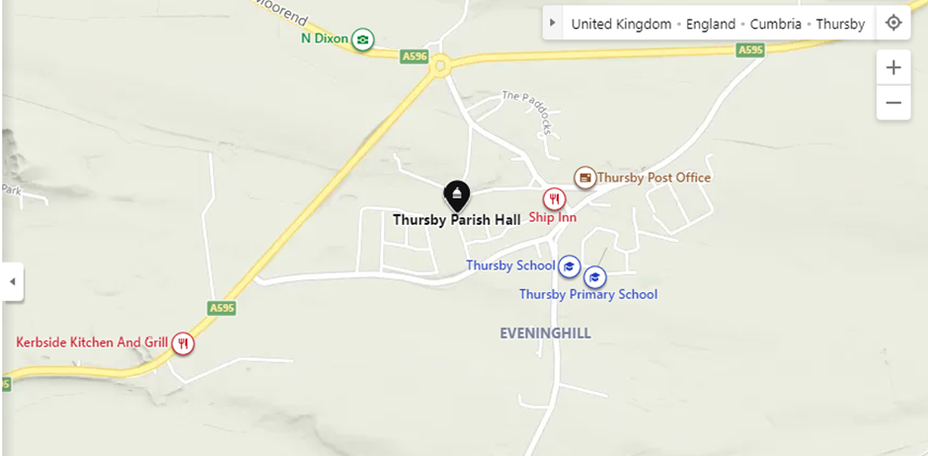

Directions:
From Carlisle
Follow A595 towards Cockermouth. Turn Right into Thursby at the start of the bypass. Follow the road past the Ship Inn. Turn Right onto Matty Lonning. Alternatively continue to Thursby Roundabout and follow instructions from Wigton.
From Wigton
Follow A596 to Thursby Roundabout. Turn into Thursby from the roundabout and Turn 1st Right to reach the Hall,
From Cockermouth
Follow A595 towards Carlisle. Turn Right into Thursby. Turn 3rd Left to reach the Hall. Alternatively continue to Thursby Roundabout and follow instructions from Wigton.
BEGINNERS AND IMPROVERS WORKSHOP SATURDAY NOVEMBER 12TH 2022

Booking Form

Please indicate the number of each attendance type you require. Payment may be made either by cheque made payable to RSCDS Carlisle and Border Branch and sent to Dr Francis Reid, 3 Melbourne Road, Carlisle. CA1 2DW or by internet bank transfer direct to our bank account (Sort Code 60-04-30; Account number 01031317; Account Holder RSCDS Carlisle & Border Branch). Please include your name and “Beg” in reference and print email contact details of all members of your group so we can confirm your place and contact you if we need to.

Please make cheques payable to RSCDS Carlisle and Border Branch.

Class 1 £5 Member No............
£6 Non-member No……….
Class 2 £5Member No............
£6 Non-member No……….
Dance £5 Member No............
£6 Non-member No……….

Total enclosed...£.........................................

Individual Details

Surname............................................... First Name (for badge)................................

Contact Details (email address preferred).....................................................................

Class 1...... Class 2...... Dance......

Surname............................................... First Name (for badge)................................

Contact Details (email address preferred).....................................................................

Class 1...... Class 2...... Dance......

Surname............................................... First Name (for badge)................................

Contact Details (email address preferred).....................................................................

Class 1...... Class 2...... Dance......

Additional names can be included overleaf

